Idea on Phase

Brainstorm & Idea Priori za on Template

|  |  |
| --- | --- |
| Date | 1 JULY 2025 |
| Team ID | LTVIP2025TMID44259 |
| Project Name | Pa ern Sense: Classifying Fabric Pa erns using  Deep Learning |
| Maximum Marks | 4 Marks |

Brainstorm & Idea Priori za on Template:

Brainstorming provides a free and open environment that encourages everyone within a team to par cipate in the crea ve thinking process that leads to problem solving. Priori zing volume over value, out-of-the-box ideas are welcome and built upon, and all par cipants are encouraged to collaborate, helping each other develop a rich amount of crea ve solu ons.

Use this template in your own brainstorming sessions so your team can unleash their imagina on and start shaping concepts even if you're not si ng in the same room.

Reference: h ps://www.mural.co/templates/brainstorm-and-idea-priori za on

Step-1: Team Gathering, Collabora on and Select the Problem Statement

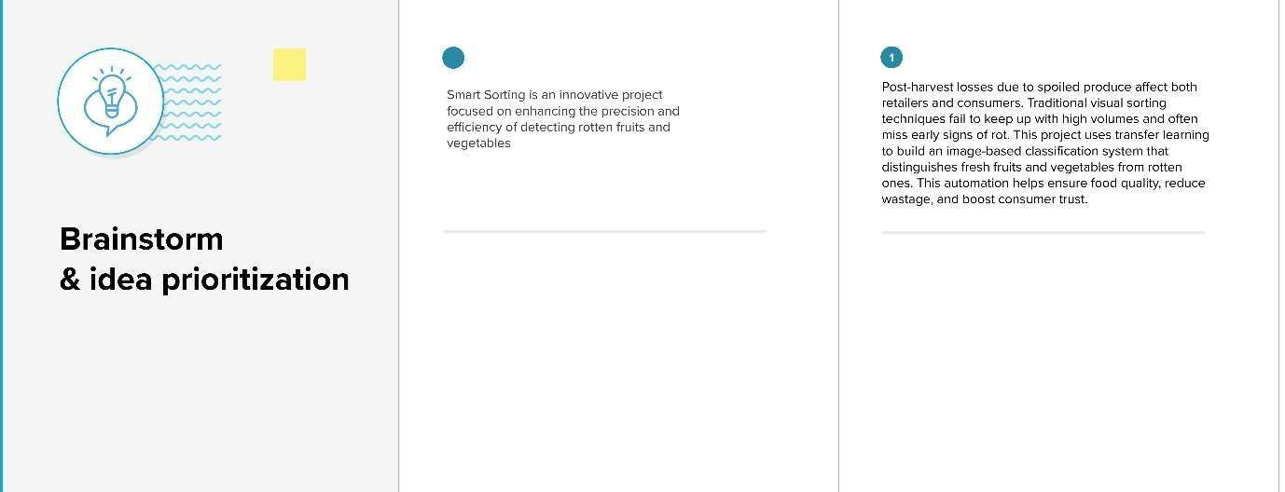

Step-2: Brainstorm, Idea Lis ng and Grouping

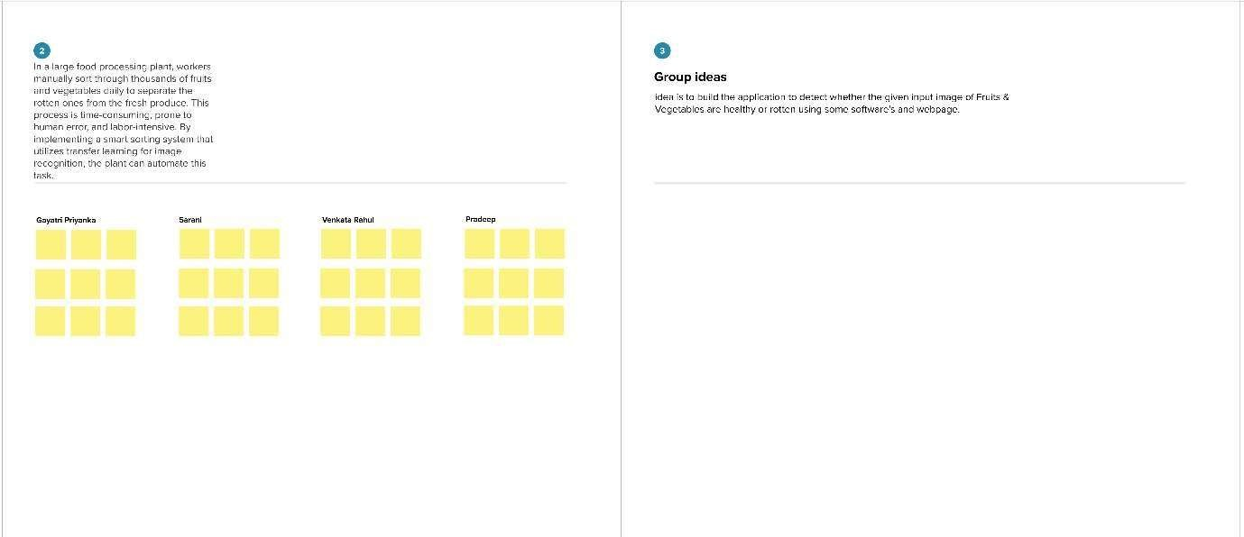

Step-3: Idea Priori za on

